*Items must be created as the serial #’s before the shipment can be received.*

In Adagio, open Inventory Control.

* Go to Receipts, Select New
* Under the Header Tab enter the invoice information, date shipment was received, Vendor#.
* Go to the Details Tab, New, Enter the Item# you created previously, cost must be the cost+ the divided shipping cost, location 1 is our yard.

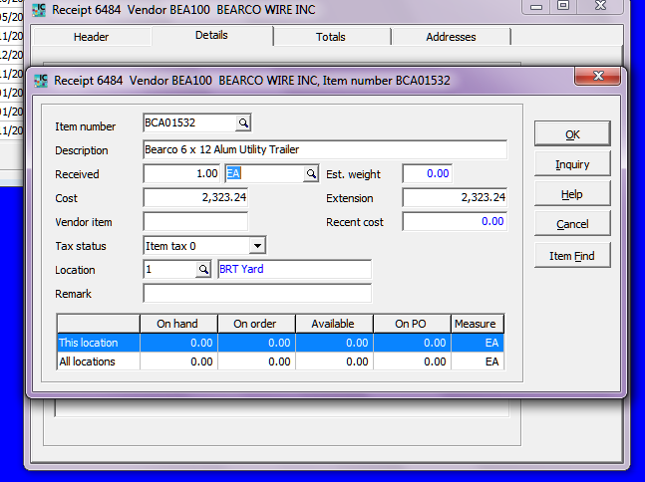

Once all trailers are entered post. When you are sure everything is correct (you have invoice and have verified prices and you have the packing slips verifying what was received, highlight the order and click complete.

